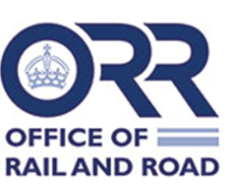

LEVEL CROSSINGS ACT 1983
THE [NAME OF OPERATOR] [NAME OF CROSSING] LEVEL CROSSING (REVOCATION) ORDER 20##
Made on [leave blank]
Coming into force on DD MONTH 20##
The Secretary of State for Transport, having been requested by [full name of operator] (“the operator”) to make an Order under section 1 of the Level Crossings Act 1983 (“the Act”) makes the following Order in exercise of his powers under the Act and of all other enabling powers, in accordance with the draft Order which accompanied the request subject to those modifications the Secretary of State thought fit to make.
- This Order may be cited as the [name of operator] [name of crossing] Level Crossing (Revocation) Order 20## and shall come into force on DD MONTH 20##.

- The [name of operator] [name of crossing] Level Crossing Order YYYY is revoked.

Signed by authority of the Secretary of State on [leave blank]

[leave blank]
Head of [leave blank], Railway Safety
Office of Rail and Road

1983 c.16

